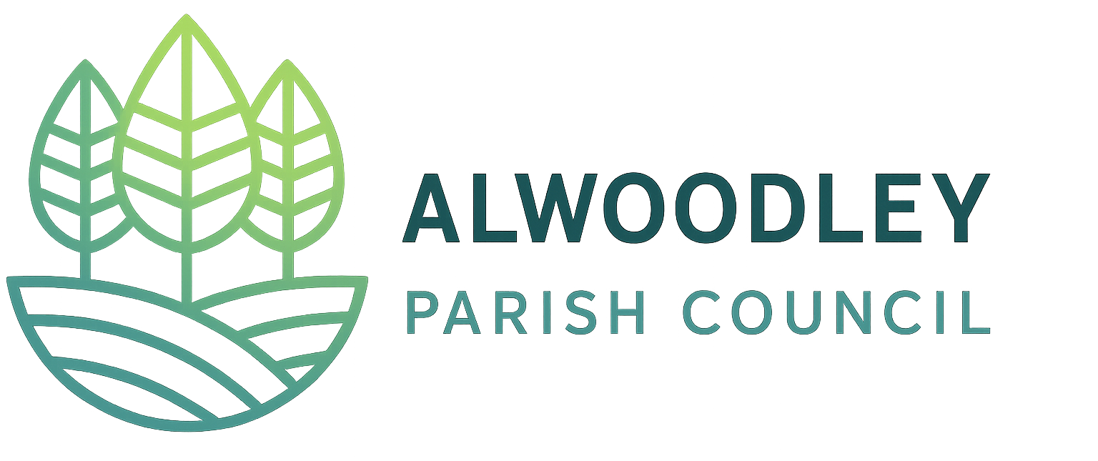

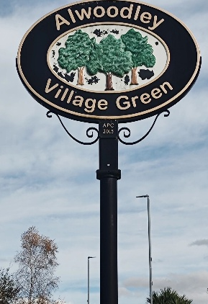
Spring - Summer 2026




Summer Band and Leeds 400 Celebrations - Sunday 21st June.

Get ready for a fantastic community celebration! Last year’s Picnic on the Green was a huge hit, and this year it’s back on Sunday 21st June on the Village Green. Local groups are invited to host stalls and we’d especially love to see our schools showcase their creativity. Enjoy a live band, community stalls, and local groups stalls. With Leeds celebrating its 400th anniversary, this milestone will be at the heart of the fun. Pack a picnic, soak up the atmosphere and join us for a brilliant day together!

To express your interest please contact our clerk at

the.clerk@alwoodleyparishcouncil.gov.uk

or send us a message via our website by scanning the QR code

alwoodleyparishcouncil.gov.uk
Newsletter

New Noticeboard on the Village Green
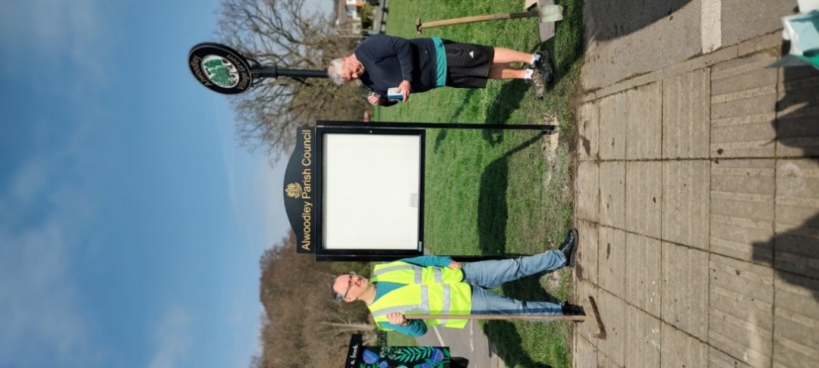

A new noticeboard has been installed on the Village Green beside the Little Library, providing a clear and accessible focal point for community information. We hope it will help keep residents informed about local news, events and activities taking place across Alwoodley.
Parish Budget 2026-27
The Parish Council budget raised from the Council Tax Precept is £64,496. This is spent on employing the Clerk, Ranger services, Grants awarded, Bands on the Green, Festive lights and other Parish initiatives.
Grants Awarded
In 2025 the following local groups were awarded grants from the Parish Council to support their activities, helping to deliver valuable services and initiatives within the community.
Recent Grants | Amount
Herd Farm  Contribution to a new assault course | £5,000
Friends of Heath Nursery Woods  Help with setup costs | £65
Leeds Rhinos  Funding for summer multi sports camps | £2,500
Alwoodley 2030  Walk to school week Healthy homes  Open gardens | £2,302
Alwoodley Scouts  Firepit & equipment | £1,067
Friends of Adel Woods  Tree removal poppers | £672
Alwoodley Allotments  Information signs | £395
St. Barnabas Contribution to a new church roof | £5,000
Total | £17,001

Play Equipment on the Village Green

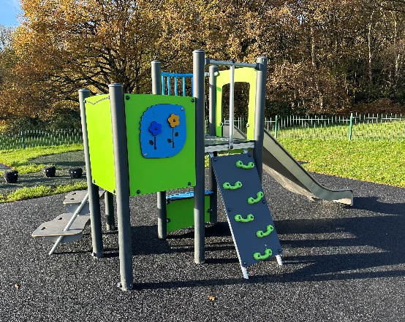
In November the Parish Council contributed £30,000 towards new play equipment on the Village Green. It is wonderful to see so many children and families enjoying these valuable additions to the community.
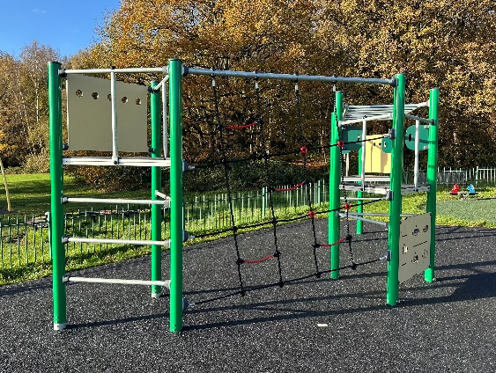

Your Parish Councillors
Parish councillors are volunteers who give their time to support and improve the Alwoodley community. They work together to represent residents, make decisions and help shape a positive future for the area.
We are delighted to welcome Geoff Downes to the Parish Council and look forward to the enthusiasm, commitment and strong community spirit he brings to supporting and improving Alwoodley for everyone.


Police and Communities Together (PACT) meetings give residents the opportunity to raise any concerns with the police.
Usually held at the ACA commencing 6.30 pm for one hour. Check our website to confirm details.
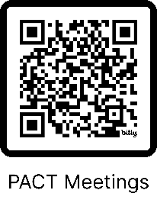

Parish Council Meetings
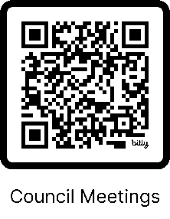

Date | Venue
11/05  AGM | Held at the ACA commencing 7pm.  Please check our website for the latest information.  The planning committee starts at 6:30pm, before the main meetings.
01/06
06/07
07/09
05/10
02/11
03/08 &
07/12
Planning
only
Our Ranger

Mark Illingworth continues to keep our parish neat and tidy. Apart from routine litter picking, repairing verge damage and removal of Himalayan Balsam around the Village Green here are some of the recent projects he has worked on.

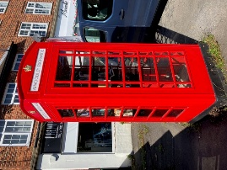
He repainted the little library telephone box on The Avenue.

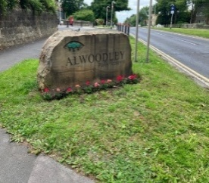
He plants flowers and bulbs around street signs and our boundary stones.

He regularly cuts away obstructions to our footpaths. Here’s before and after pictures of King Lane.
Brass Band concert
27th September

There will be a Brass Band Concert on the Village Green in September, and we hope to make this an Autumn festive event. Please keep an eye on the notice boards for further details.

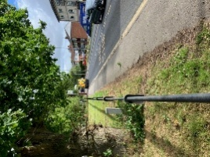
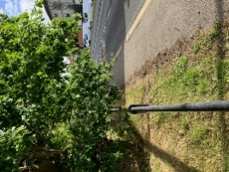

If you think there’s something Mark should tackle please get in touch with him through the website.

