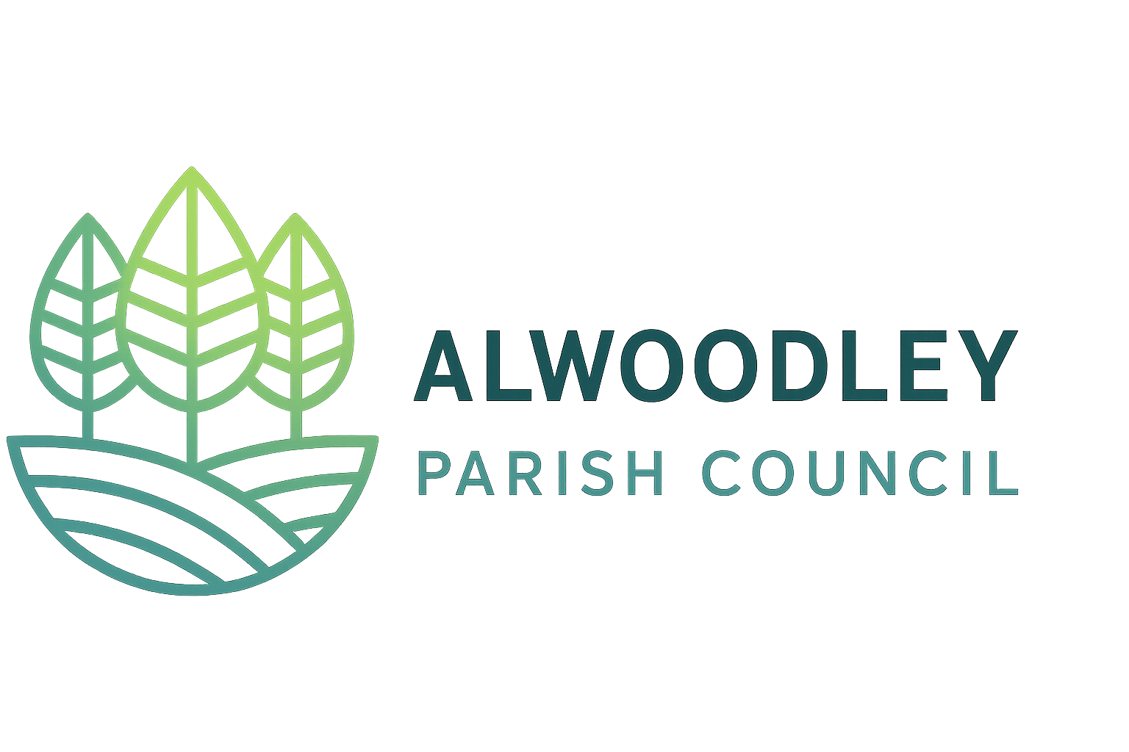
Alwoodley Parish Council

Sponsorship and Advertising Policy

Purpose
This policy provides a framework for councillors on the legal position, risks and approach to event sponsorship and newsletter advertising.

Legal Position
The Council may:
- Accept financial or in-kind contributions to support its functions
- Use sponsorship to offset costs of community events and activities
- Rely on powers including Acceptance of Gifts, Provision of Entertainment, and Subsidiary Powers

Key Risks and Restrictions
The Council must not:
- Enter arrangements that create a conflict of interest
- Allow political influence or promotion
- Accept sponsorship from inappropriate or harmful sectors
- Undertake activity that may present reputational risk, particularly during pre-election periods

Governance and Compliance Requirements
All arrangements must:
- Be supported by a formal written agreement
- Clearly define any benefits or recognition provided
- Be assessed for VAT implications where applicable
- Require appropriate public liability insurance for event participation
- Ensure full declaration of interests by members
This ensures compliance, minimal VAT exposure, and a community-focused approach.

Newsletter Advertising Framework
Objective:
To generate modest income while maintaining the newsletter as a council communication tool.
Principles:
- No endorsement of advertised goods or services
- Advertising limited to a maximum of 25% of content
- Priority given to local businesses
Exclusions:
- Conflicts of interest
- Political content
- Inappropriate or harmful products
- Discriminatory or offensive material
Administration:
- VAT applies to advertising income
- Transparent rate structure to be reviewed annually
- Advance payment required
- Clerk authorised to manage acceptance

Example Recommended Approach - Community Picnic Example
It is recommended that the Council:
- Seeks support from local businesses in the form of donations
- Provides simple acknowledgement only
- Avoids structured advertising or commercial packages

Operational Requirements
Requirement | What Needs to Happen (Practical Action)
Written Agreement | Prepare and sign a simple contract for every sponsor. Clearly state what the Council will provide (e.g. logo placement, mention in programme) and what the sponsor will provide (money or support).
VAT Compliance | Check if the sponsor is receiving advertising or other commercial benefits. If yes, treat this as VAT applicable and record it properly. If it is only a simple thank you mention, VAT is usually not required.
Insurance | Before the event, obtain a copy of the sponsor’s Public Liability Insurance (minimum £5 million) if they will be present or active on site. Do not allow participation without this.
Transparency | Ask councillors to declare any connection to a sponsor. Record this in the meeting minutes and ensure the individual does not take part in the decision.

Conclusion
Sponsorship and advertising can support council activities where arrangements are transparent, neutral, and community focused.

Adopted: [date]
Review Date: [date]

