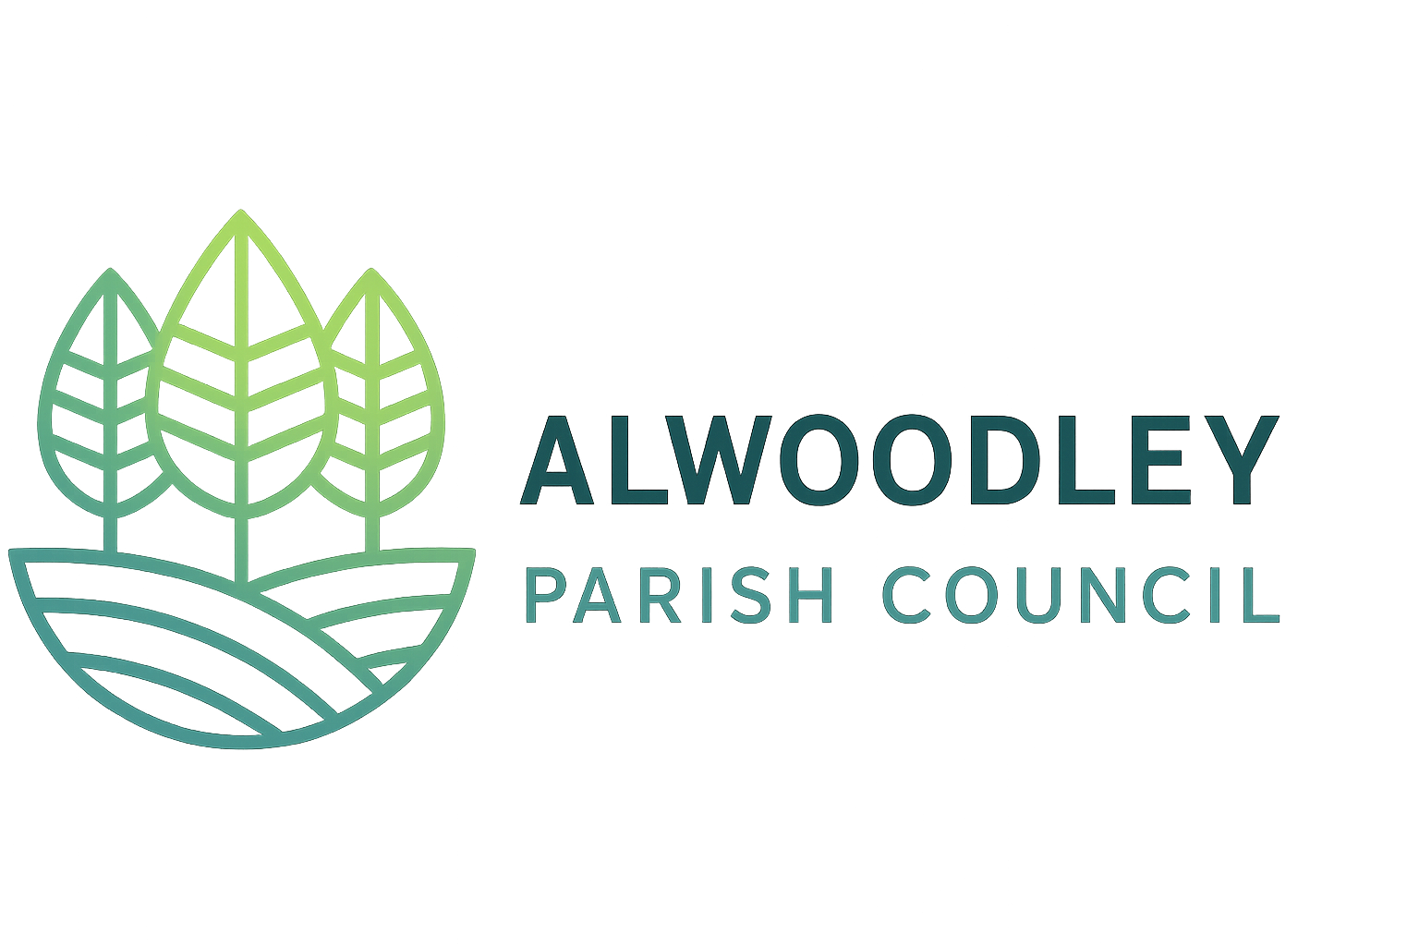
Alwoodley Parish Council
Sponsorship and Donations Policy
1. Purpose
This policy provides a framework for councillors and the Clerk on the law, risks, and financial controls regarding corporate donations, non-commercial sponsorship, and business support for print materials and community events.
2. Legal Position & Statutory Powers
Because the Council does not hold the General Power of Competence (GPC), it can only accept funds or publish materials where statutory authority exists:
- Section 139 (Local Government Act 1972): Authorises the Council to accept and hold gifts or donations made to discharge its functions or for the benefit of local inhabitants.
- Section 142(1B) (Local Government Act 1972): Authorises the Council to publish information relating to local government matters and local affairs, such as the newsletter.
- Section 145 (Local Government Act 1972): Authorises the Council to provide or contribute to the cost of community entertainments, arts, festivals, and recreational events.
3. Risks and Restrictions
The Council must avoid activities that constitute commercial trading or advertising. The Council must not:
- Sell commercial advertising space: The Council cannot sell advertising space, publish business logos, print web links, or distribute corporate promotional copy in its newsletter or at events.
- Offer commercial marketing benefits: The Council cannot enter into contracts where a company receives a marketing advantage in exchange for cash.
- Allow political or inappropriate influence: No support will be accepted from political entities or industries that present a risk to the community.
4. Newsletter Support Framework
To offset the production costs of the newsletter, the Council operates under a Donation Model.
- Nature of Support: Local businesses may make a financial donation under Section 139 of the LGA 1972 to cover up to 100% of printing and distribution costs.
- Allowable Acknowledgment: In return for a donation, the Council may provide a factual text-only thank-you acknowledgment.
- Permitted Wording Example: "The Parish Council acknowledges the financial support of (Business Name) toward the production costs of this newsletter."
- Prohibited Content: The acknowledgment must never include company logos, phone numbers, addresses, website URLs, or descriptions of products or services.
- VAT Compliance: Because the newsletter remains a non-business activity with no supply of advertising, the Council can reclaim 100% of the printer’s VAT via HMRC Form VAT126 (Section 33, VAT Act 1994).
5. Community Event Sponsorship Framework
When seeking financial or in-kind support for community events, the following guidelines apply:
Requirement | Action
Written Agreement | Prepare and sign a "Donation & Acknowledgment Agreement". This must state that the business is providing a donation, and that the Council will provide a text-only thank-you in the event programme or on a supporter banner. It must state no promotional rights are granted.
Procurement & VAT | The Council must contract, receive invoices for, and pay all event expenses from its own bank account. Provided the event charges no entry fee and provides no commercial advertising, it is a non-business activity, and all input VAT can be reclaimed via Form VAT126.
Transparency | Any corporate support must be approved and minuted at a public Council meeting. Councillors must declare any connections to a donor business and recuse themselves from the vote.

6. Conclusion
By restricting corporate relationships to donations and text-only acknowledgments, Alwoodley Parish Council protects its right to reclaim VAT on public expenses and ensures all activities remain within its legal powers.

Adopted: (Date)
Review Date: (Date)

