ALWOODLEY PARISH COUNCIL
DRAFT Alwoodley Parish Council Minutes
5th October 2026, 7pm,
Alwoodley Community Hall, Parish Council Room
60 The Avenue, LS17 7NZ
PRESENT: Councillor Catherine Borse, Councillor Ian Dickinson, Councillor Geoffrey Downes, Councillor Richard Hainsworth, Councillor Daniel Jordan (Chair), Councillor David Towns, Councillor Steven Wright
APOLOGIES , None received.
IN ATTENDANCE: Councillor Neil Buckly, Ward Councillor, 3 members of the public, Jennifer Walper Roberts, Clerk
There was a period of public participation prior to the start of the meeting during which the Council heard presentations from Leeds Rhinos Foundation and Alwoodley Community Association representatives.

2627/96 Welcome. The Chair opened the meeting and welcomed all present.
2627/97 Audio or Visual Recording of Meeting. The Chair reminded attendees of the Council’s policy regarding the audio and visual recording of the meeting.
2627/98 Apologies for Absence
- Apologies received: None.
- Approval of Reasons: None to approve.
2627/99 Declarations of Interest and Applications for Dispensation
- Applications for Dispensation: None received
- Declarations of Interest:
Cllr Pritchard declared an interest in the ACA Application because she is a trustee and did not vote on the grant application that organisation submitted.

2627/100 Minutes of Previous Meeting. RESOLVED: That the minutes of the Parish Council Meeting held on 7th September 2026 be confirmed and signed as a true record.
2627/101 Ward Member Updates
Received updates from Ward Members regarding Leeds City Council (LCC) matters relevant to the Parish Council including: Mowing regime to improve with new contractors; awaiting map of relaxed mowing regime; payment to police from Ward Councillors to increase motoring and other offence; Boulders to be put installed around Cranmer bank playground to reduce vehicular access
2627/102 Electoral Matters. Noted that chair is awaiting resignation letter.
2627/103 Ongoing Issues and Actions
- Action Log: Reviewed the action log; RESOLVED that staffing panel would bring Lone Working and Home Working policies to the next meeting.
- Action Plan: Reviewed progress on the action plan and agreed further action including:
- Noted that the Council has reviewed the Bronze award Application
- RESOLVED that the Council has reviewed the Bronze Award Application and confirmed that it has all the necessary documentation and information in place and is ready for submission.
- Training Plan & Inventory: Noted that this has been updated and was included with the agenda papers.
- Mailing List: NOTED that the mailing list increased by 37 subscribers in September, reaching 145 subscribers (up from 82 in February) due to event and hedgehog highway initiative.
- Notice Board Policy: NOTED that the approved policy was added to the website, emailed to local organisations, and posted to Facebook.
- Lloyds Account Closure: NOTED that this is in progress.
- Grant Awarding Policy:
  - RESOLVED to approve the revised Grant Awarding Policy, incorporating clarification on item 13 regarding logo/acknowledgement requirements for grantees and improved formatting.
  - RESOLVED to instruct Parish Clerk to research any limits to grant funding and to add discussion about grant limits to the next meeting.
- Grant Application Form Formatting: NOTED minor formatting, spelling, and grammar revisions made by Cllr Dickinson.
- Grantee Logo: RESOLVED to approve the official logo for grantees to use on marketing materials for funded projects.
- Volunteer Policy: Deferred until the next meeting.
- Surgery Rota: RESOLVED to adopt the Surgery Rota; assigned councillors to confirm dates and venues within two weeks.
- Meeting Dates: RESOLVED to approve the 2027 meeting dates (all 2nd Monday, except Oct 4): Jan 11, Feb 08, Mar 08, Apr 12, May 17 - , Jun 14, Jul 12, Aug 09 (planning committee only), Sep 13, Oct 04*, November 8th, No APC meeting in Dec 13 (planning meeting only), but keep room reserved
2627/104 External Audit Findings 2025/26
NOTED: The External Auditor’s Report and Certificate and Statement Regarding Audit Findings for the 2025/26 financial year, and that the Notice of Conclusion of Audit has been published on the website and noticeboards.
2627/105 Financial Matters
- Bank Balances (as of 30th September 2026):
  - Virgin Current Account: £41,719.08
  - Lloyds Deposit Account: £90,068.00
- Bank Reconciliations: NOTED the signed bank reconciliation packs for August and September 2026.
- Receipts & Payments: NOTED receipts and payments made in September 2026.
- Banking Transition: Received an update from the Chair regarding the reserves account transfer to Virgin.
- Grants Report: Received the update on grants awarded and remaining funds.
- Grant Application (Alwoodley Community Association): Re-considered the application and RESOLVED to defer consideration application until the organisation hears back from funder.
- Committed Spend Report: Received and noted the Committed Spend Report.
RESOLVED TO APPROVE Recommended mid-year virement Motions contained in the Committed Spend Report:
RESOLVED TO APPROVE Motion 1: Income Budget Adjustment (VAT), a downward adjustment of the FY 2026/27 Income Budget on Line 705 (VAT) from £6,000.00 to £0.00; noting that the £6,000.00 reclaim was received in FY 2025/26, and forms part of the opening General Reserves, and adopting the best-practice, accounting principle that VAT reclaims are cost-neutral reimbursements and should be budgeted at £0.00 in future financial years.
RESOLVED TO APPROVE Motion 2: Cost Centre 200 (Regular Admin Costs) Virements. To approve the following internal line-item budget virements within Cost Centre 200 (Regular Admin Costs) to reallocate £465.00 in surplus funds to cover line overspends and estimated payroll service costs. Including: Transfer £195.28 from Line 208 (IT - Monthly Subscriptions), £120.00 from Line 209 (IT - Accounting Software), and £149.72 from Line 206 (Books/Training) to:
- Line 202 (Room Hire - Parish Council): £95.00
- Line 211 (Payroll Services): £202.00
- Line 213 (Memberships): £168.00

RESOLVED TO APPROVE Motion 3: Cost Centre 300 (Maintenance) Virements. To approve the following internal line-item budget virements within Cost Centre 300. (Maintenance) to reallocate £204.00 to cover the overspend on Line 302 (Dog Waste Bags):
- Transfer £85.73 from Line 304 (Wild Flower Beds) (confirming no further
- expenditure for FY 2026/27) and £118.27 from Line 301 (Asset Maintenance) to Line 302 (Dog Waste Bags).

RESOLVED TO APPROVE Motion 4: Cost Centre 500 (Events) Virements and approve the following internal line-item budget virement within Cost Centre 500, including:
- Reallocate £356.66 in surplus funds to cover the overspend on Line 501(Band Concert / Community Events): Transfer £110.18 from Line 502 (Winter Event) and £246.48 from Line 503 (Annual Meeting) to Line 501 (Band Concert / Community Events)

RESOLVED TO APPROVE Motion 5: Cost Centre 100 (Salary & Wages) Payment & Virements including following financial adjustments for Cost Centre 100 (Salary & Wages):
1. September Overtime Payment & Funding: To approve the payment of £538.08 gross (24 additional hours at £22.42/hr, SCP 31) for the Clerk/RFO for September 2026, funded by allocating £286.62 in unbudgeted in-year income (£226.62 from Line 703 Interest Income and £60.00 from Line 708 Complaint Compensation) alongside a budget virement of £251.46 from Line 205 (Stationery) to Cost Centre 100.

2. Internal Salary Line Rebalancing: To reallocate £2,594.20 internally within Cost Centre 100 by transferring available surpluses from Line 101 (Salary: £622.37), Line 104 (£642.78), Line 105 (£161.55), and Line 106 (£1,167.50) directly to Line 102 (PAYE Contributions: £2,528.39) and Line 103 (Employee NI: £65.81).

- Schedule of Payments: RESOLVED to approve the October Schedule of Payments and corresponding invoices.
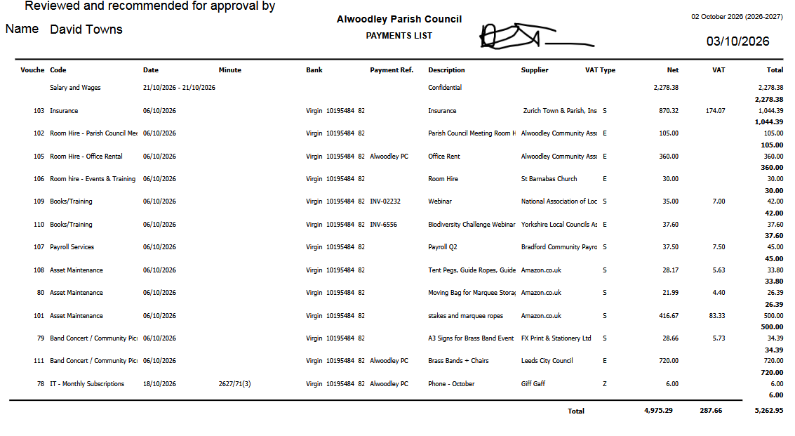
2627/106 Matters Requested by Councillors
- E-Scooter Signage: RESOLVED to instruct the CLERK to ask LCC to install signage on the village green prohibiting e-scooter use on footpaths/green spaces.
- Community Resilience Plan: RESOLVED that Cllr Borse will investigate further what would be involved move forward with drafting a Community Response/Resilience Plan and established a working party to complete a draft by the end of 2026.
- Budgeting Workshop Task & Finish Group: RESOLVED to form a Task and Finish Working Party to prepare content, costings, and the agenda for the November budgeting workshop consisting of Cllr Jordan, Cllr Hainsworth, Cllr Downes.
2627/107 Committees and Working Parties
- Planning Committee:
  - Received progress updates on the Action Plan.
- Environment, Sustainability and Biodiversity Working Party:
  - Received updates on Hedgehog Highways and progress on the action plan.
  - RESOLVED to up to £300 for additional hedgehog houses.
- Communications and Engagement Working Party:
  - Received recap of the September.
  - Festive Lights: RESOLVED to approve the quote of £2,475 + VAT, comprising:
    - APC motif storage/PAT/install/removal: £217
    - Hire/install/recovery of 6 large motifs (£330 each): £1,980
    - Tommy motif hire: £278
  - Received noticeboard updates and action plan progress.

- Staffing Panel:
  - Standing Order 19(c): RESOLVED to amend Standing Order 19(c) to replace 'Employment Panel' with 'Staffing Panel'.
  - Professional Development Plan: RESOLVED to approve the plan.
  - Operational Line Management: RESOLVED to delegate day-to-day operational line management (leave, sickness, minor TOIL up to 5–10 hrs/month) to the Chair of the Staffing Panel.
  - Earmarked Reserve: RESOLVED to establish a Staffing Contingency Earmarked Reserve of £5,000 via transfer from General Reserves.
  - Clerk/RFO Additional Hours: RESOLVED to approve payment of £538.08 (24 hrs @ £22.42/hr, SCP 31) for September 2026 additional hours. (See budget virement)

- Leeds Beckett Landscape Architecture Working Party:
  - Received a report on the initial meeting with students regarding the Village Green project.
  - RESOLVED that councillors would send feedback to Jen by Wednesday to send to students.
2627/108 Parish Ranger Matters
- Received operational updates from the Parish Ranger. Ranger has bulbs and will get planting.
- Discussed potential biodiversity improvement activities for the Ranger to undertake. Ranger has supported distributing hedgehog houses, and is scheduled to help drill hedgehog highway holds in spring.
2627/109 Community Organisations & Outside Bodies. Received updates and noted councillor representation:
- Alwoodley Community Forum: Noted Cllr Dickinson has stepped down. No updates.
- PACT/Police: (Cllrs Dickinson, Downes, Pritchard). Cllr Downes noted efforts to reduce altered bikes used for crime.
- ACA Liaison: (Cllr Pritchard). None
- Alwoodley Social Club: (Cllr Pritchard). None
- Leeds Parks & Green Spaces Forum: Updates noted (Cllr Wright). None
- YLCA Liaison: Updates noted (Cllr Jordan). None
- Training & Development Liaison: Updates noted (Cllr Towns). None
- Allotments: None.
- Incredible Edible Liaison: (Cllr Jennings) shared their plans to plant 10 fruit trees and asked for a letter of support from the PC to go to LCC.
RESOLVED that the Parish Council supports Incredible Edibles proposal to plant 10 fruit trees near the incredible edible beds and will draft a letter of support.
- Town & Parish Meeting Liaison (Outer NE): (Cllrs Jordan, Towns). None
2627/110 Correspondence Received
- Neighbourhood Plan Enquiry: Reviewed resident query regarding boundary changes and future engagement.
- Planning Application Objection (26/04979/FU): Received objection and noted planning committee comments for LCC portal.
2627/111 Items for Next Agenda
Members notified the Clerk of items to be included on the next meeting agenda:
Staffing contingency plan, Volunteer Policy, Lone and Home Working Policies, Appointing New Liaison to the Alwoodley Community Forum, Co-Option of New Councillor
2627/112 Date of Next Meeting
The next Full Council Meeting was confirmed for Monday, 2nd November 2026 at 7:00 PM.
Meeting Closed at 9:00pm

