Hedgehog Highways Update

16 Hedgehog Houses were delivered/collected throughout the parish. 7 people outside the parish requested them. 5 people who signed up haven’t yet provided their addresses and I’ve sent a reminder email. The next step is to order more hedgehog houses per last meetings resolution and further promote in the newsletter.
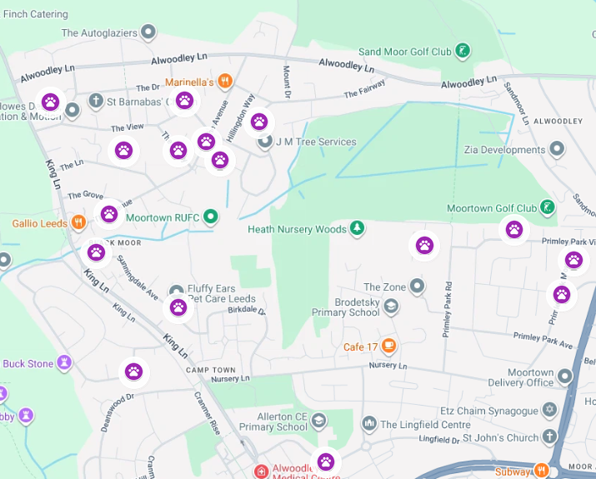

12 people signed up to be street captains. 8 of those live within the Parish.
22 people were interested in monitoring and tracking. Of those, 17 live within the parish boundaries.
16 people signed up to have holes drilled in their fences in late winter/early spring.
Next steps are to encourage street-wide participation by reaching out to people who wanted to get their neighbours involved (street captains) to drive more hedgehog highway requests and hole-drilling sign ups in concentrated areas for nature connectivity. The street with the most people will get the trackers.
There is less take up in the Birkdale’s/Sunningdale’s, Buckstones, Primelys, Wentworths, so perhaps we could do some targeted outreach in those areas.
9 people were interested in trees and I forwarded them info for the Alwoodley 2030 tree initiative.

