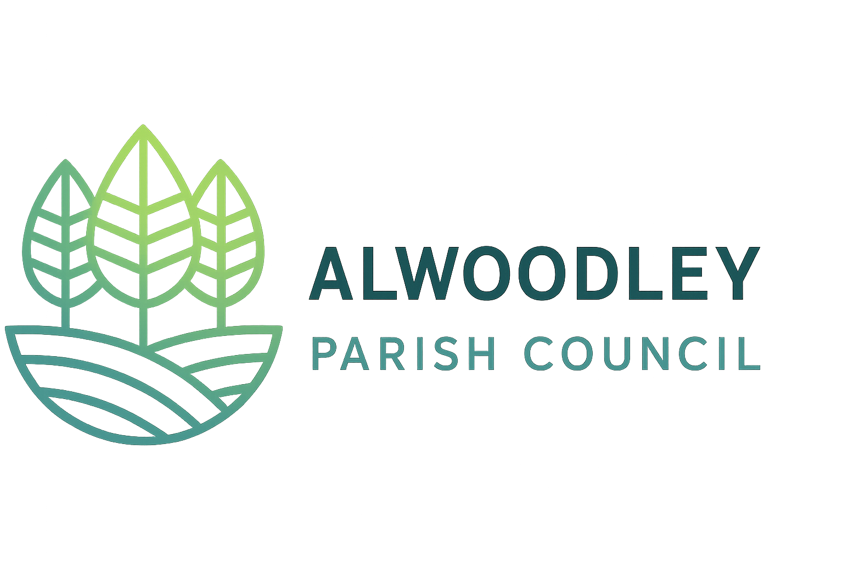
Alwoodley Parish Council

Risk assessment for:

Councillor Public Surgeries
The main risks at a surgery are manageable with simple steps, and the council should agree them before the first session.
Venue: to be confirmed Assessed by: to be completed by the Clerk Review: before the first session and then once a year
Risk | Who could be affected | What we will do | Rating
Aggressive or threatening behaviour | Councillors and visitors | Use a public venue with other people around. Sit near the door. End the meeting calmly if needed. Record the incident and tell the Clerk. | Medium
Councillor working alone | Councillors | Have two councillors present where possible. Tell the Clerk the time and place. Check in afterwards. | Medium
Private conversations overheard | Residents | Use a room or quiet area where others cannot hear. | Medium
Personal information handled badly | Residents | Only note what is needed. Store notes securely. Follow UK GDPR. Use council email addresses only. | Medium
Child or vulnerable adult attends or raises a concern | Residents | Councillors know who to report to. Follow the council's safeguarding steps. | Medium
Too many people at once | Everyone | Encourage booked appointments. Set start and end times. Keep to the venue's capacity. | Low
Fire or accidents at the venue | Everyone | Check the venue's fire and safety arrangements. Know where the exits are. | Low
Unfair claims about what was said | Councillors | Have two councillors present. Keep short factual notes. Remind residents that decisions are made by the full council. | Low
Insurance does not cover surgeries | The council | Check cover with the insurer before the first session. | Medium

Rating key:
Low means very unlikely to cause harm.
Medium means it could happen and needs the steps above.
High means do not go ahead until it is fixed.

